**Team PDQ**

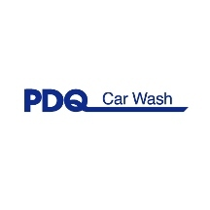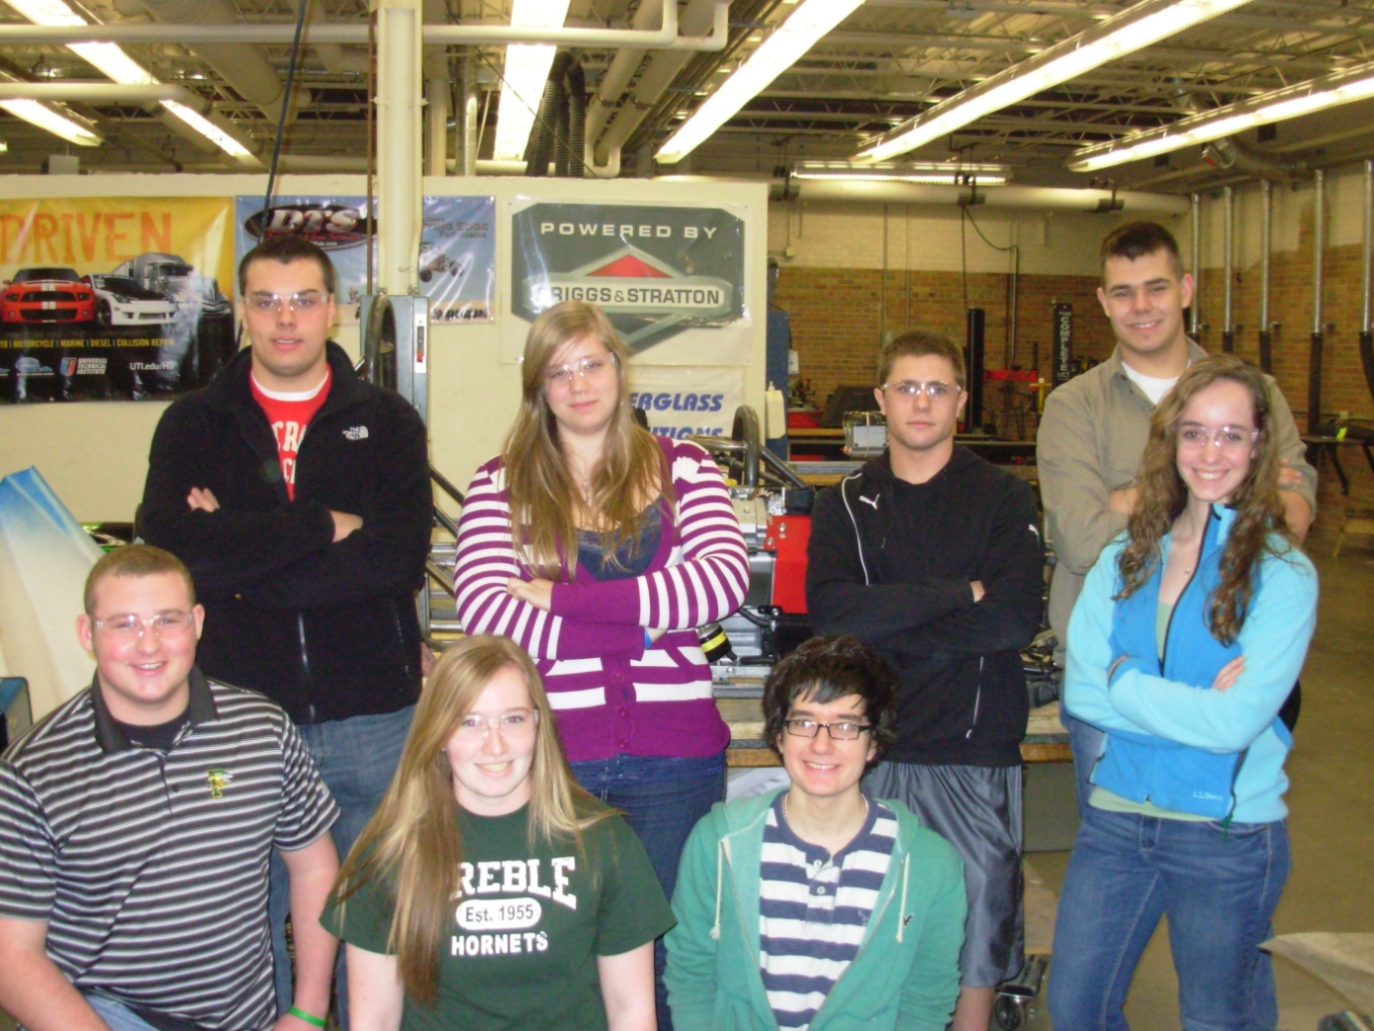

Top Row from Left to Right: Tyler Noel, Arianna Grant, Zach Nellis, Jake Mears

Bottom: Evan Thielen, Kayla Heraly, Don Clark, Lizzy Lovering

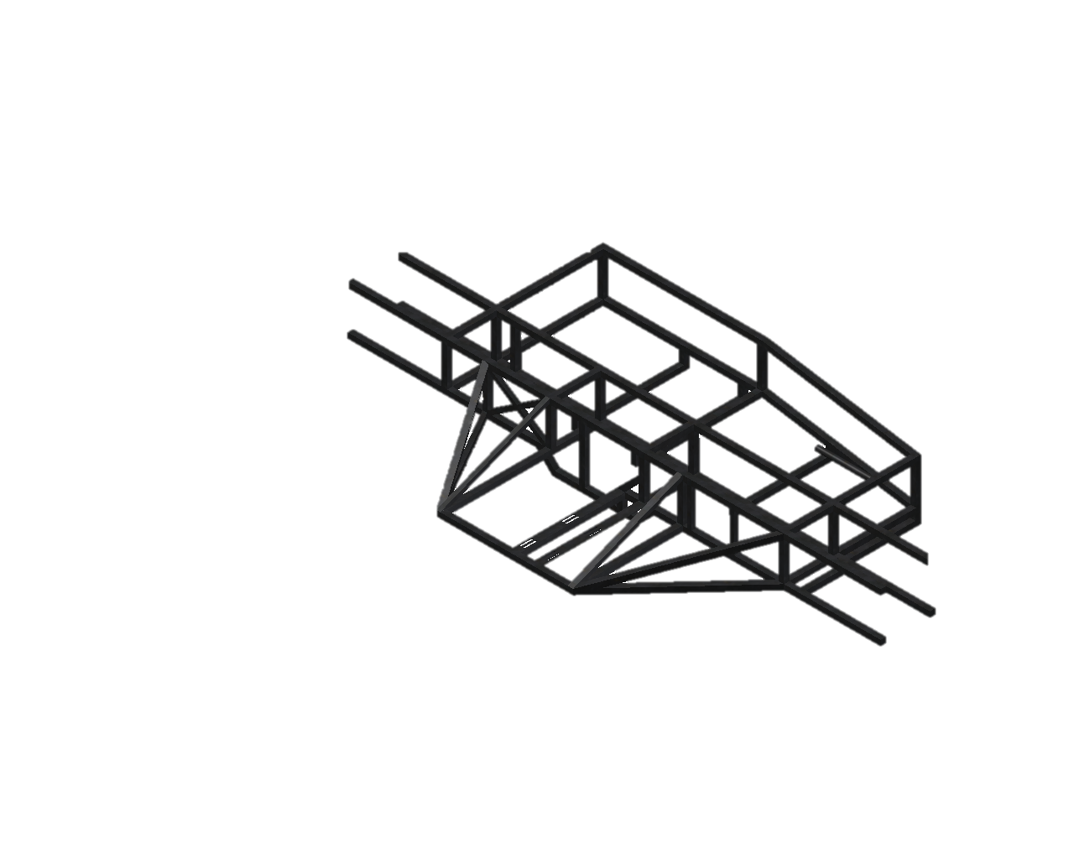

Starting with the center tower, the welding could begin. Eight .125” plates were also used to hold the central frame in line. Once that was done, the cock pit and engine mount could be assembled and welded to the central frame. 1” square tubing was used for the frame. The roll bars were fabricated out of 1.5” steel tubing. After, small plates were added to make mounting the roll bars more secure.

For the first semester of the 2011-2012 school years we have been designing and building a Formula High School roadster. Formula High School is a program for high school students to design, build, and test racecars. The cars will compete on April 28 and April 29 at Road America. Our group consists of an 8 person team combining seniors and juniors. The chassis needed to be redesigned from last year’s model. Once the design was finalized the steel could be ordered so we could get started.

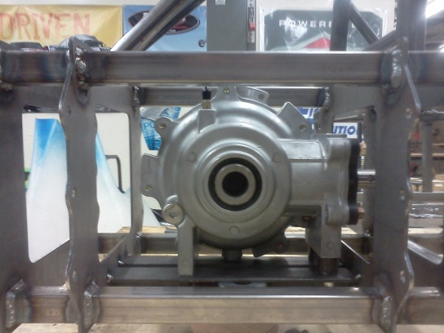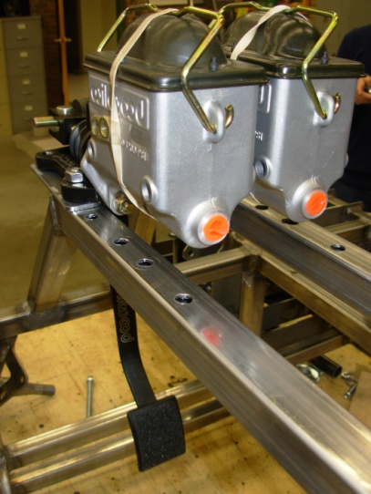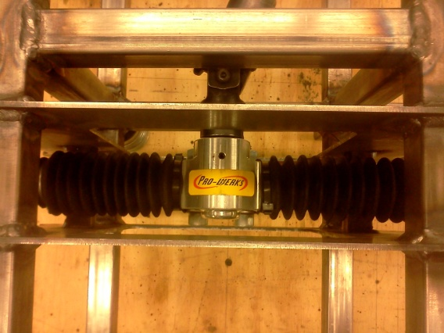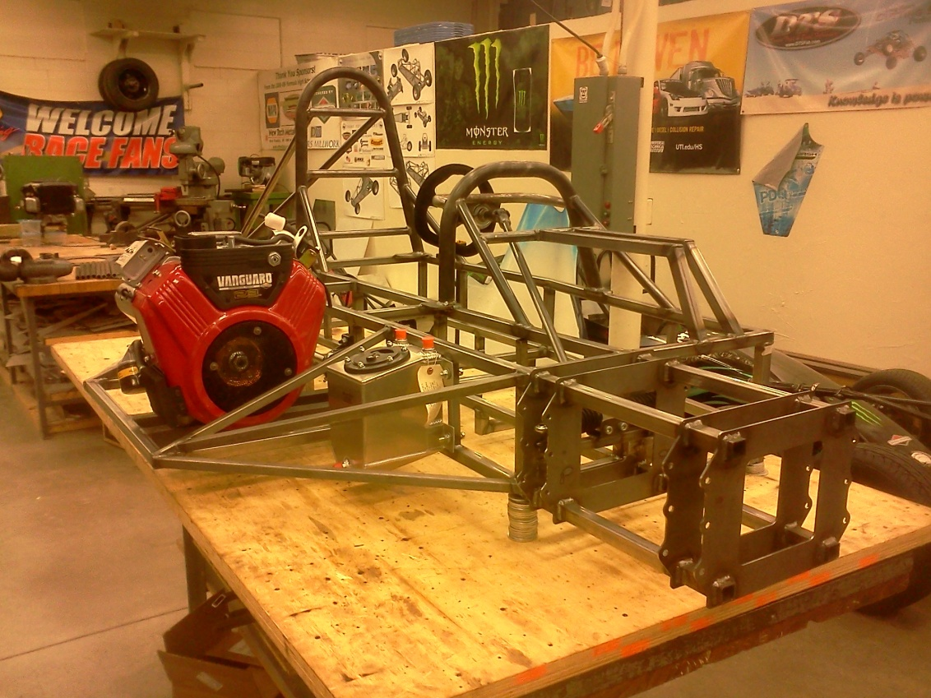End

Brakes from Wilwood

Differential from Hilliard Corp.

Our Rack and Pinion mount

This is our car with the roll bars, engine, fuel cell, and steering all mounted.

Welding the chassis provided our team a few road bumps along the way. The cock pit was reengineered to save space and weight; the changes included complex curves that were difficult to bend. The floor had to be adapted to accommodate our tallest member at 6’ 6”. The seat this year is custom to the car and cockpit. The break and throttle needed to be adjustable to fit our smallest teammate at 5’ 3”. The rack and pinion steering was added with a custom mount, which went through many obstacles in fabrication. The engine was bolted so the jack shaft could be mounted. We purchased the differential from the Hilliard Corp. and it was mounted.



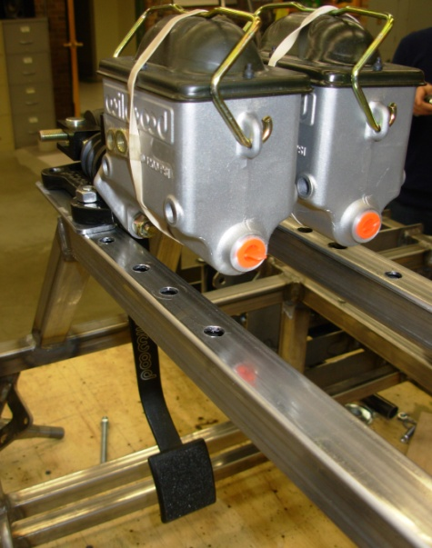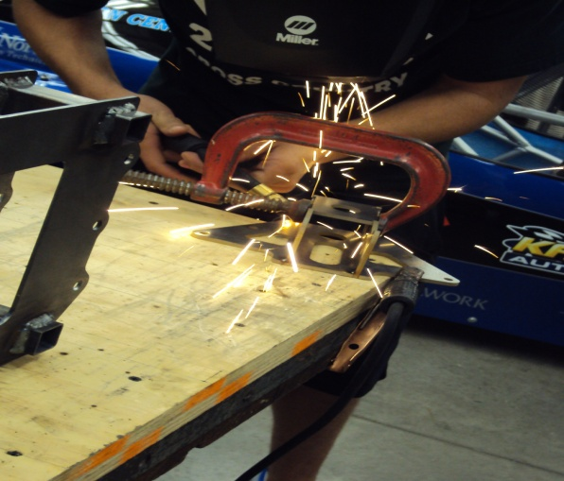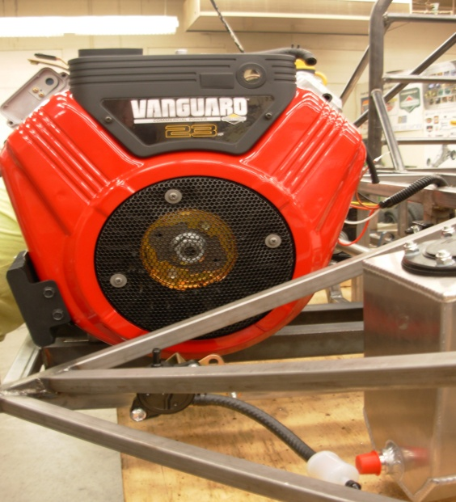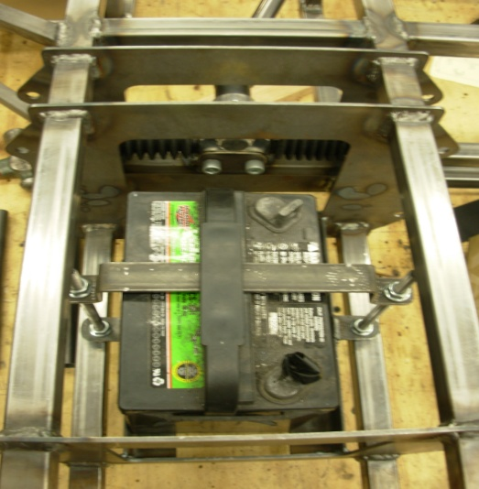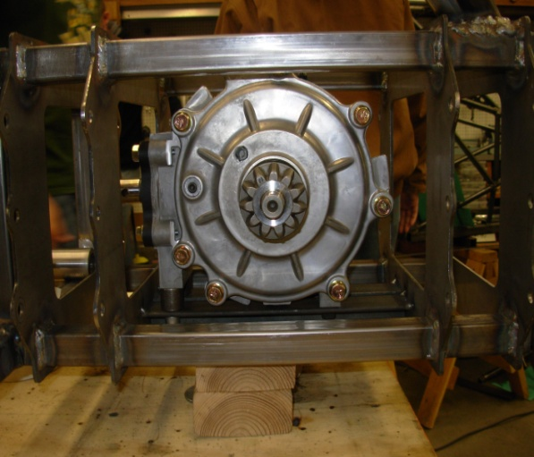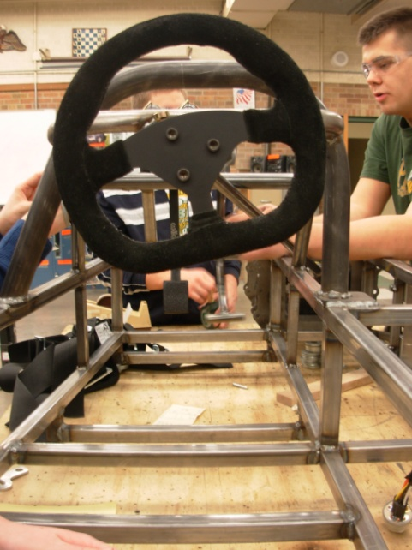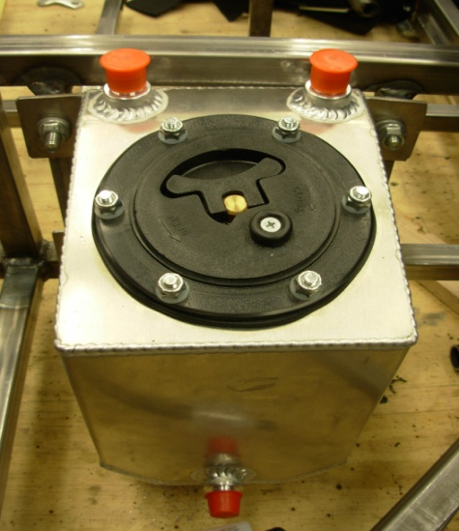

Miscellaneous Pictures

Right: Battery Mount

Above: Welding Front Uprights

Left: Steering Wheel

Above: Fuel cell gas tank

Above: Vanguard Engine supplied by Briggs and Stratton

Above: Master Cylinder

We would like to acknowledge and thank our sponsors!



